Board Minutes
December 18, 2025

The regular meeting of the Crawford County Board of Road Commissioners was held at their office at 500 Huron Street on Thursday, December 18 at 4:30 p.m., Present: Commissioner Hanson, Commissioner Jones, Vice Chairman Summers, Chairman Halstead. Absent: Commissioner Larson. Administrative staff present: Managing Director Babcock, Clerk of the Board, Kaitlyn Pratt, Engineer Technician, Matthew Gabriel. Public Attending: Dorothy Frederick, County Commissioner, Duncan Gray.

It was moved by Chairman Halstead and supported by Commissioner Hanson to approve the December 18, 2025; Crawford County Road Commission Agenda as presented. Roll Call: Larson absent, Halstead yea, Hanson yea, Jones yea, Summers yea. Motion Carried.

It was moved by Chairman Halstead and supported by Vice Chairman Summers to approve the December 4, 2025, Board Minutes as presented Roll Call: Larson absent, Halstead yea, Hanson yea, Jones yea, Summers yea. Motion Carried.

Accounts Payable Voucher #6 in the amount of $318,693.08 was moved to pay by Vice Chairman Summers and supported by Commissioner Jones. Roll Call: Larson absent, Halstead yea, Hanson yea, Jones yea, Summers yea. Motion Carried.

Accounts Payable Voucher #6-1 in the amount of $1,787.00 was moved to pay by Commissioner Hanson and supported by Chairman Halstead. Roll Call: Larson absent, Halstead yea, Hanson yea, Jones yea, Summers yea. Motion Carried.

Accounts Payable Voucher #6-2 in the amount of $15,923.00 was moved to pay by Chairman Halstead and supported by Vice Chairman Summers. Roll Call: Larson absent, Halstead yea, Hanson yea, Jones yea, Summers yea. Motion Carried.

Managing Director Babcock reported this item as the final phase of the Industrial Drive project, there may be one additional item due to remaining financial closeout matters, but the project is nearing completion.

Cash Flow: None

Accounts Receivables: Chairman Halstead inquired how unpaid accounts would be handled and how long balances remain outstanding before legal action. Managing Director Babcock explained that for some accounts, the Road Commission may consult the attorney. If legal action would cost more than recovery, the balance would be written off but noted for future dealings. Managing Director Babcock also stated accounts over 60 days are reviewed, and at 90 days they typically enter a collection period.

BLADE AND BRINE REPORT: None

PUBLIC COMMENTS: County Commissioner, Dorothy Frederick addressed the Board regarding a private road used by Dial-A-Ride. She explained that Dial-A-Ride vehicles have been traveling down Matthes Road, a private road, causing ruts and damage. The elderly residents maintain the road themselves and previously sent a letter to Dial-A-Ride’s director without response. County Commissioner Frederick asked that Dial-A-Ride again be informed that the road is private, noting that service had stopped for about a year after prior communication. Managing Director Babcock clarified that the Road Commission does not work on private roads and agreed to contact Julie at Dial-A-Ride to inform them they are damaging a private road.

NEW BUSINESS:
South Branch Township Road Program: Managing Director Babcock reported that South Branch Township submitted its proposed road improvement projects for the coming year. Engineer Technician Matt will begin preparing estimates when time allows. Appreciation was expressed for the township’s continued participation in the road program.

North Down River Road over Big Creek Bridge Replacement: Managing Director Babcock presented a resolution showing the total project estimate to be $957,000, the Road Commissions contribution would be $47,856 as well as being responsible for engineering.

Vice Chaiman Summers moved to accept the North Down River Road over Big Creek Superstructure Replacement resolution and allow Managing Director Babcock to sign the contract and was supported by Commissioner Hanson . Roll Call: Larson absent, Halstead yea, Hanson yea, Jones abstain, Summers yea. Motion Carried.

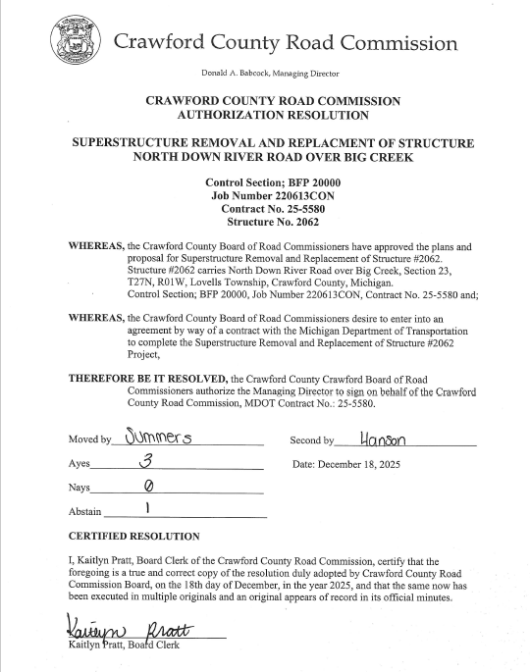

Beaver Creek Fire Chief Letter:
Managing Director Babcock presented a letter from the Beaver Creek Fire Chief regarding the most recent winter storm. Chairman Halstead stated he had written a response proceeded to read it aloud. Chairman Halstead noted the intensity and short duration of the storm was intense. Snow accumulation was packed down by traffic countywide, the Road Commission has a younger crew due to retirement, with ongoing training. He expressed support for staff and their efforts during the storm. Managing Director Babcock added that staff responded well, with no issues getting employees in, though some equipment challenges occurred, which is normal. He also stated salt is less effective in extreme cold, requiring sand/salt mixtures until temperatures rise. Commissioner Hanson stated the response letter was well written but emphasized that concerns from the community should be communicated directly, to allow for timely discussion. Vice Chairman Summers noted road conditions were more affected by ice buildup after scraping rather than snow depth, stating storms of this magnitude seem uncommon and people are not accustomed to them. After further discussion the Board agreed for Chairman Halstead’s response letter to be sent.
MANAGING DIRECTOR COMMENTS:
- Ron Lohrer’s retirement party will be held the following day at noon, weather permitting.
- Water main work is currently on hold.
Electrical contractors are working on Industrial Drive to provide power.

COMMISSIONER COMMENTS:
Commissioner Larson – Absent.

Chairman Halstead- acknowledged the upcoming retirement of Ron Lohrer and expressed appreciation for his years of service to the Road Commission. He extended best wishes as he begins the next chapter of his life. Chairman Halstead also addressed current Road Commission staff, stating that despite differing public opinions, employees continue to do an outstanding job. He emphasized his appreciation for their dedication, particularly their willingness to work long hours and remain away from their families during holidays to ensure primary roads remain open and safe for travel.

Vice Chairman Summers – noted complaints from snowmobilers due to snow being pushed far off the shoulders, indicating effective plowing.

Commissioner Hanson–None

Commissioner Jones – expressed concerns regarding gravel road shoulders being built up approximately two feet high, creating tunnel-like conditions.

There being no further business to come before the Board Vice Chairman Summers declared the meeting adjourned at 5:00 p.m.

_________________________________________ ____________________________________________
Ryan Halstead, Chairman Kaitlyn Pratt, Clerk of the Board

