Board Minutes
November 6, 2025

The regular meeting of the Crawford County Board of Road Commissioners was held at their office at 500 Huron Street on Thursday, November 6 at 4:30 p.m., Present: Chairman Halstead, Commissioner Hanson, Commissioner Jones. Absent: Vice Chairman Summers, Commissioner Larson. Administrative staff present: Managing Director Babcock, Clerk of the Board, Kaitlyn Pratt, Engineer Technician, Matt Gabriel Public Attending: Dorothy Frederick, Crawford County Commissioner, Tom Coors, Maple Forest Township Supervisor.

It was moved by Commissioner Jones and supported by Commissioner Hanson to approve the November 6, 2025; Crawford County Road Commission Agenda as presented. Roll Call: Larson absent, Halstead yea, Hanson yea, Jones yea, Summers absent. Motion Carried.

It was moved by Commissioner Jones and supported by Commissioner Hanson to approve the October 23, 2025, Board Minutes as presented Roll Call: Larson absent, Halstead yea, Hanson yea, Jones yea, Summers absent. Motion Carried.

Accounts Payable Voucher #3 in the amount of $116,235.84 was moved to pay by Chairman Halstead and supported by Commissioner Hanson. Roll Call: Larson absent, Halstead yea, Hanson yea, Jones yea, Summers absent. Motion Carried.

Accounts Payable Voucher #3-1 in the amount of $557.00 was moved to pay by Commission Hanson and supported by Commissioner Jones. Roll Call: Larson absent, Halstead yea, Hanson yea, Jones yea, Summers absent. Motion Carried.

Accounts Payable Voucher #3-2 in the amount of $35,141.75 was moved to pay by Commission Hanson and supported by Commissioner Jones. Roll Call: Larson absent, Halstead yea, Hanson yea, Jones yea, Summers absent. Motion Carried.

Cash Flow: None

Accounts Receivables: None

Blade and Brine Report: None

PUBLIC COMMENTS:
Maple Forest Township Supervisor discussed confusion regarding the status of House Road, whether certain portions between House Road and Marker Road are county seasonal or private. He has consulted the County and Lighthouse Title and requested clarification on which parts the Road Commission maintains and receives funds for. Mr. Coors added that a resident installed a gate south of Marker Road, causing concern among locals who use the route for access. He is seeking clarification on whether the gate blocks a public or private section of the road. Managing Director Babcock will review the roads and maps to provide clarification.

NEW BUSINESS:
Adoption – Resolution for Transportation Asset Management Plan
Managing Director Babcock explained that the Transportation Asset Management Plan has been in development since 2019 and is required by the Federal Highway Administration. Compliance is necessary to continue receiving MTF funds. He noted that while the plan outlines ideal maintenance and resurfacing cycles, funding limitations make those timelines unrealistic for Crawford County. The plan serves as a comprehensive summary of current practices, including financial data, paving and culvert inventories, and will provide a foundation for future updates.
A motion was made by Commissioner Hanson and supported by Chairman Halstead to authorize Chairman Halstead and Managing Director Babcock to sign the Proof of Acceptance for the certification of the Transportation Asset Management Plan. Motion carried. Roll Call: Larson absent, Halstead yea, Hanson yea, Jones yea, Summers absent. Motion Carried.

Chairman Halstead then made a motion, supported by Commissioner Hanson, to adopt the resolution for the Transportation Asset Management Plan, confirming that the plan will be reviewed and updated at least every three years. Roll Call: Larson absent, Halstead yea, Hanson yea, Jones yea, Summers absent. Motion Carried.

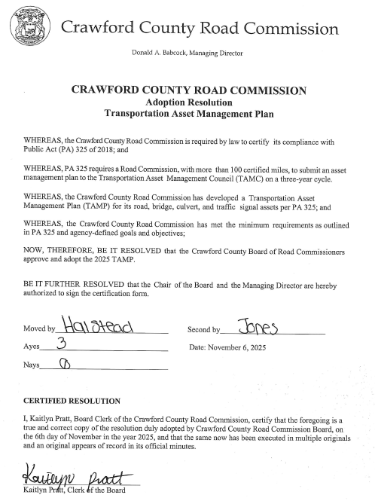

Jack Bulmer – Vacation Payout Request
Managing Director Babcock explained that Jack Bulmer has exceeded his vacation carryover balance due to being on worker’s compensation and unable to use his time. Although unused vacation time is typically forfeited, in this case payment is appropriate since he was unable to use it and will receive full payout upon retirement regardless. Managing Director Babcock confirmed that similar requests have been approved in the past.
A motion was made by Chairman Halstead and supported by Commissioner Jones to approve the vacation payout for Jack Bulmer. Roll Call: Larson absent, Halstead yea, Hanson yea, Jones yea, Summers absent. Motion Carried.

It was moved by Chairman Halstead and seconded by Commissioner Jones extend the Beaver Removal bid with Steven Sendek for the current price of $6,000.00 per year. Roll Call: Larson absent, Halstead yea, Hanson yea, Jones yea, Summers absent. Motion Carried.

It was moved by Chairman Halstead and supported by Commissioner Jones to approve the 2026 board meeting schedule with the dates of the December 31, 2025, meeting moved to December 30, 2025, and the December 31, 2026, meeting moved to December 30, 2026. Roll Call: Larson absent, Halstead yea, Hanson yea, Jones yea, Summers absent. Motion Carried

OLD BUSINESS:

MANAGING DIRECTOR COMMENTS:
The crew is preparing for winter, getting trucks ready.

Work continues on the timber bid for the Lovells area, though progress is slow due to needed survey work for boundary marking.

Miller Pipeline has completed rerouting the main and asphalt patching over the sinkhole in front of the Frederic Inn; the area will be left through winter and properly repaired in spring.

FEMA reimbursement from the ice storm remains on hold.

The North Down River Road project over Big Creek is scheduled for the January bid letting.

Industrial Drive is nearly complete, pending relocation of a few signs before final balancing and documentation.

Next spring, township permits for the watermain project will be renewed, and contractors will be required to complete each stage before moving forward.

Toebe Construction is boring under the East Branch near the Fish Hatchery Bridge. Uncertainty about allowing work to continue past Roberts Road was noted. Materials stored near the airport must be removed from the right-of-way before winter plowing.

M&M Excavating is finishing work in Sherwood Forest—paving and shoulders are done, with topsoil, mailbox replacement, and final touches underway.

The Evergreen culvert replacement is postponed due to a conflict with the gas main and paving schedule; the area will be temporarily paved for winter, then reopened and repaired in spring. Crews will monitor water levels and may use pumps as needed.

COMMISSIONER COMMENTS:
Commissioner Larson – Absent.
Vice Chairman Summers – Absent
Commissioner Hanson– None
Commissioner Jones – None
Chaiman Halstead – None

There being no further business to come before the Board Chairman Halstead declared the meeting adjourned at 5:00 p.m.

_________________________________________ ____________________________________________
Ryan Halstead, Chairman Kaitlyn Pratt, Clerk of the Board

